

Assignment Code: DA-AG-012

Advanced Excel| Assignment

Total Marks: 200

Question 1 : Explain the difference between Absolute, Relative, and Mixed Cell Referencing in Excel with examples.

Answer :

Relative Reference (A1)
- Changes automatically when copied to another cell.
- Example:
  - Formula in C2: =A2+B2
  - Copied to C3 → =A3+B3
- Used when the formula should adjust based on position.
Absolute Reference ($A$1)
- Does not change when copied.
- Example:
  - Formula: =A2*$B$1
  - $B$1 remains fixed.
- Used for constants like tax rate, discount, etc.
Mixed Reference ($A1 or A$1)
- Either row or column remains fixed.
- Example:
  - $A1 → Column fixed, row changes
  - A$1 → Row fixed, column changes
- Used in tables like multiplication tables or structured calculations.

Question 2 : What is a Macro in Excel? How does it help in automation?
Answer :
A Macro is a set of recorded or written instructions (VBA code) that automates repetitive tasks in Excel.
Benefits of Macros
- Saves time
- Reduces human error
- Automates formatting, calculations, and reporting
- Executes tasks with a single click
Example
If you repeatedly:
- Apply formatting
- Highlight values
- Generate reports
A macro can perform all these steps automatically.

Question 3 : What are Text Functions in Excel? Mention any five with examples.
Answer :

Function |  |  |  | Purpose | Example
LEFT() |  |  |  | Extracts characters from left | =LEFT("Excel",2) → Ex
RIGHT() |  |  |  | Extracts from right | =RIGHT("Excel",2) → el
MID() |  |  |  | Extracts from middle | =MID("Excel",2,2) → xc
LEN() |  |  |  | Counts characters | =LEN("Excel") → 5
CONCAT() |  |  |  | Joins text | =CONCAT("Data"," Analyst")

Question 4 : What is the use of Scenario Manager in decision making?
Answer :

Scenario Manager allows users to compare different outcomes by changing input values.
Uses
- Financial planning
- Budget forecasting
- Risk analysis
- What-if analysis
Example
You can create scenarios like:
- Best Case
- Worst Case
- Expected Case
And instantly compare profits, costs, or revenue.

Question 5 : Define the purpose of VLOOKUP and HLOOKUP. How are they different from XLOOKUP? Which among XLOOKUP and INDEX-MATCH is best while usage?
Answer :

VLOOKUP
- Searches vertically
- Syntax: =VLOOKUP(A2,Table,2,FALSE)
- Cannot look left
HLOOKUP
- Searches horizontally
- Syntax: =HLOOKUP(A1,Table,2,FALSE)
XLOOKUP
- Modern replacement
- Can look left/right
- Faster and flexible
- Syntax:
=XLOOKUP(A2,A:A,B:B)
INDEX-MATCH
- More powerful than VLOOKUP
- Works in any direction
- Syntax:
=INDEX(B:B,MATCH(A2,A:A,0))
Best Choice:
- XLOOKUP (simpler & modern)
- INDEX-MATCH (best for complex datasets)

Question 6 : Create a dataset of 8 employees with joining dates. Use the dummy dataset to calculate their experience in years and months.
Answer :

Dummy Dataset
Employee | Joining Date | Experience
Emp1 | 01-01-2018
Emp2 | 15-03-2019
Emp3 | 10-07-2020
Emp4 | 05-02-2017
Emp5 | 20-11-2016
Emp6 | 12-08-2021
Emp7 | 01-06-2015
Emp8 | 25-09-2018
Formula
=DATEDIF(B2,TODAY(),"Y")&" Years "&DATEDIF(B2,TODAY(),"YM")&" Months"

Question 7 : You are provided with a dataset containing details of 100 road accidents.Design a Road Accident Analysis Dashboard using Pivot Tables and Slicers in Excel.
Answer :

Dataset Link

Row Labels | Sum of Casualties
Auto-Rickshaw | 36
Bicycle | 38
Bus | 34
Car | 50
Motorcycle | 57
Truck | 37
Grand Total | 252

Row Labels | Count of Accident ID
Animal Hit | 27
Collision | 20
Object Hit | 13
Overturn | 25
Pedestrian Hit | 15
Grand Total | 100

Row Labels | Count of Accident ID
Fatal | 24
Minor | 26
Moderate | 22
Severe | 28
Grand Total | 100

Row Labels | Count of Accident ID
Ahmedabad | 9
Bangalore | 14
Chennai | 12
Delhi | 9
Hyderabad | 17
Kolkata | 13
Mumbai | 15
Pune | 11
Grand Total | 100

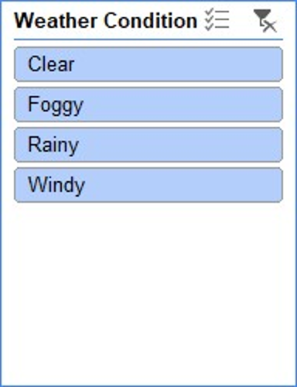
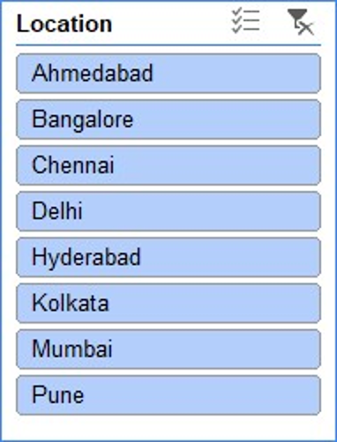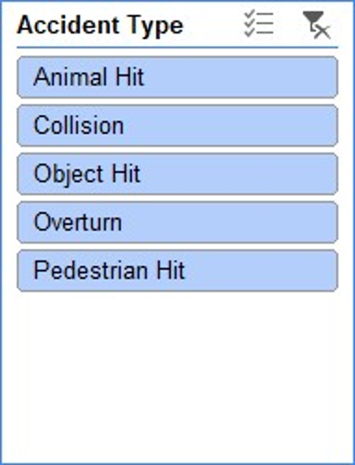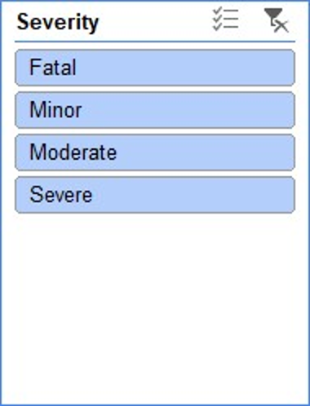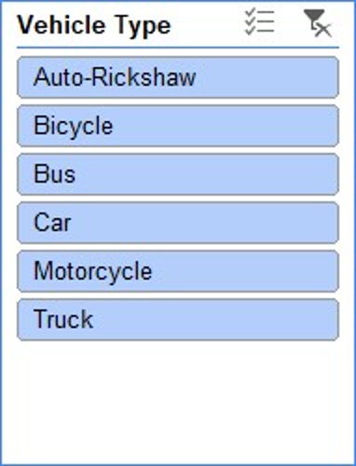

Question 8 : Create a table of 10 products with stock levels. Use Macros to highlight:
- Low stock (less than 10 units) in red
- Overstock (more than 50 units) in green.
Answer :

Sample Data
Product | Stock
A | 5
B | 60
C | 15
... | ...
Macro Code
Sub StockHighlight()
Dim cell As Range
For Each cell In Range("B2:B11")
If cell.Value < 10 Then
cell.Interior.Color = vbRed
ElseIf cell.Value > 50 Then
cell.Interior.Color = vbGreen
End If
Next cell
End Sub

Question 9 : You are given a dataset : Create a drop-down list of product names in a separate cell using Data Validation, and write a formula in the adjacent cell so that when a product is selected from the drop-down, its corresponding price is automatically displayed.
Dataset Link

Answer :

Step 1: Understanding the Dataset
The dataset contains multiple columns such as Order ID, Customer Name, Region, Product Category, Product Name, and Unit Price.
For this task:
- Product Name column is used to create the drop-down list.
- Unit Price column is used to display the price.

Step 2: Creating a Drop-down List Using Data Validation
- Select a blank cell where the drop-down list is required (for example, Cell N2).
- Go to the Data tab on the Excel ribbon.
- Click on Data Validation.
- In the Allow field, select List.
- In the Source box, select the range containing product names (for example, F2:F51).
- Click OK.
A drop-down list containing all product names is now created.

Step 3: Displaying the Unit Price Automatically
- Select the cell next to the drop-down list (for example, Cell O2).
- Enter the following formula:
=XLOOKUP(N2, F2:F51, H2:H51)
Formula Explanation:
- N2 refers to the selected product name from the drop-down list.
- F2:F51 is the Product Name column.
- H2:H51 is the Unit Price column.
- The XLOOKUP function searches for the selected product and returns its corresponding unit price.
(Alternatively, VLOOKUP can be used in older versions of Excel.)

Result:
When a product name is selected from the drop-down list, the corresponding unit price is automatically displayed in the adjacent cell.

Question 10 : Case Scenario :-
Dataset Link
You are a data analyst working for a retail firm. You’ve received a sales dataset that includes customer transactions from various regions and product categories. Your job is to analyze this data, clean inconsistencies, extract insights, and build visual reports.
Task :
- Apply data validation in the Units Sold column to ensure only values between 1 and 20 are allowed.
- Highlight rows where Profit > ₹5000
- Highlight any phone number that is not exactly 10 digits
- Find the Revenue generated by each product and also label according to revenue generated as “High”, “Medium”, “Low”.
- Find the profit percentage up to two decimal places.
- Show Total Revenue and Total Profit by Region.
- Show Average Units Sold per Product Category.

Answer :

Row Labels | Sum of Revenue | Sum of Profit
East | 304204.77 | 65576.37
North | 290473.09 | 53496.26
South | 278867.13 | 52548.77
West | 263623.37 | 53733.27
Grand Total | 1137168.36 | 225354.67

Row Labels | Average of Units Sold
Clothing | 7.225
Electronics | 8.115384615
Furniture | 7.764705882
Grand Total | 7.64

